

**American International University- Bangladesh**

**Introduction to Database**

**Assignment Topic:** Air Accessing Management System (Case Study & ER Diagram)

**Submitted by**:

|  |
| --- |
| **ID**  **Name** |
| |  |  | | --- | --- | | 20-43627-2 | Ahmed,Tousif | | 20-43632-2 | Rahat,Md.Saimun Islam | | 20-43634-2 | Abir,Ittishaf Bashar | | 20-43671-2 | Siddqua,Shinzon | | 20-43679-2 | Adikta,Ridita Zaman | |
|  |

Submitted To:

**Kawser Irom Rushee**

**Case Study**

In an air accessing management system there are several sectors where we can see main airport sector, employed workers, airplane owner, airlines, flight schedule and so many other sectors. Airport location, city, country, airport name, code number; these things are stored in the airport sector. Available planes and flights are recorded in airplane and flight sector. Airplane registration number, types and specific seats are recorded in this sector. There are several owners and airplanes in an airport. Airlines location, code number, owner’s e-mail, phone number and name are also recorded in the files. All these works are done by specific workers in the specific sectors. Several employees are selected for each sectors. A worker’s name, hiring date, ID, salary everything are noted. Flights get booked by booking officers. Departure date, flight number, arrival times, destination all get confirmed by the booking officer. One flight get booked by many passengers. The booking officers provides them the tickets, where passenger name, price, order number and flight number are mentioned. One ticket for one passenger. Passenger name, date of birth, phone number, order number, address and gender get recorded in the booking sector. One passenger can book many tickets.

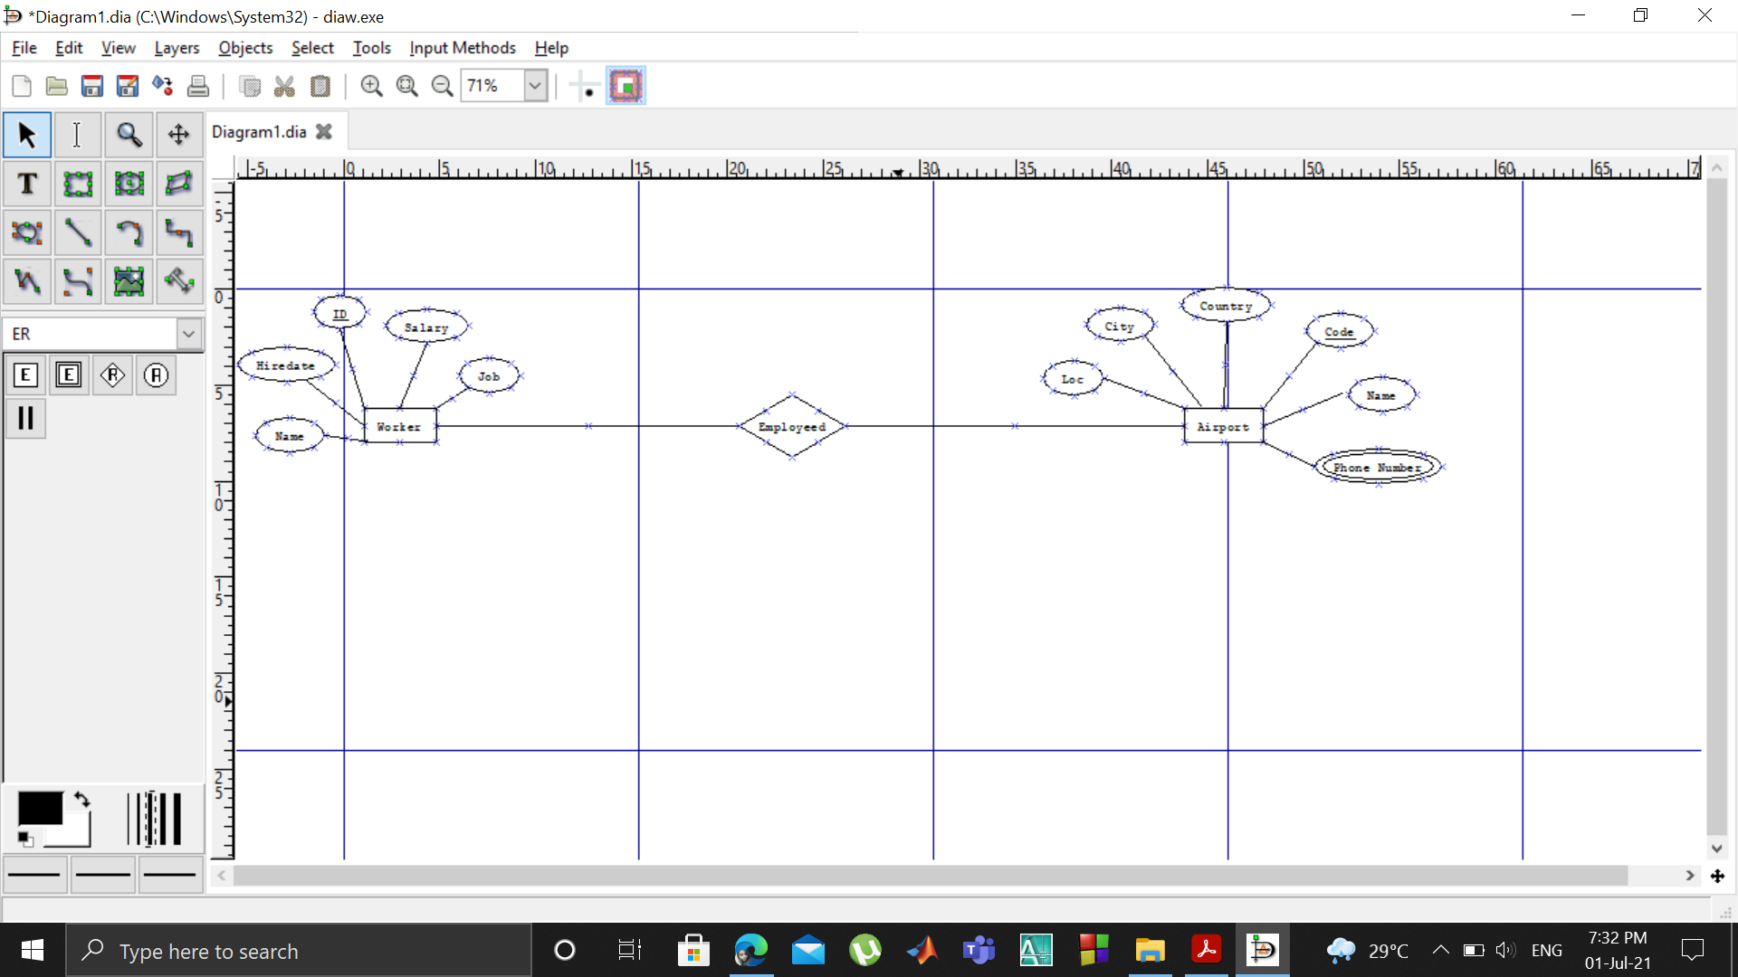

**(Starting)**

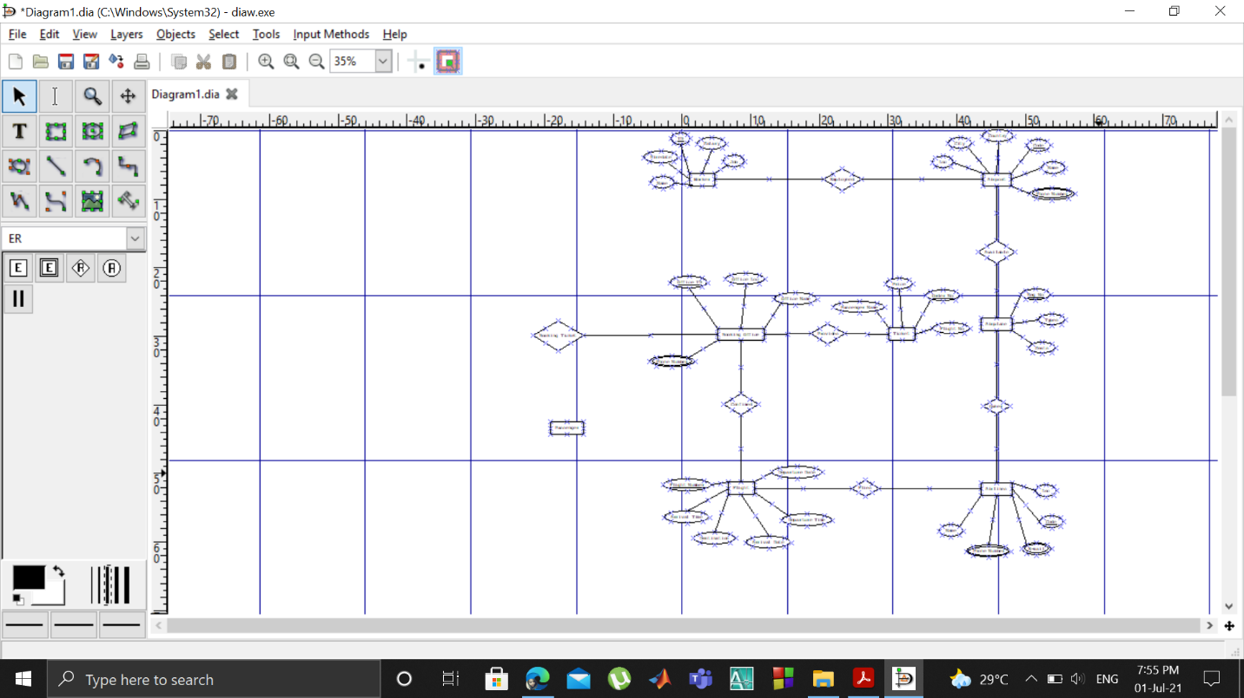

**(Ending)**

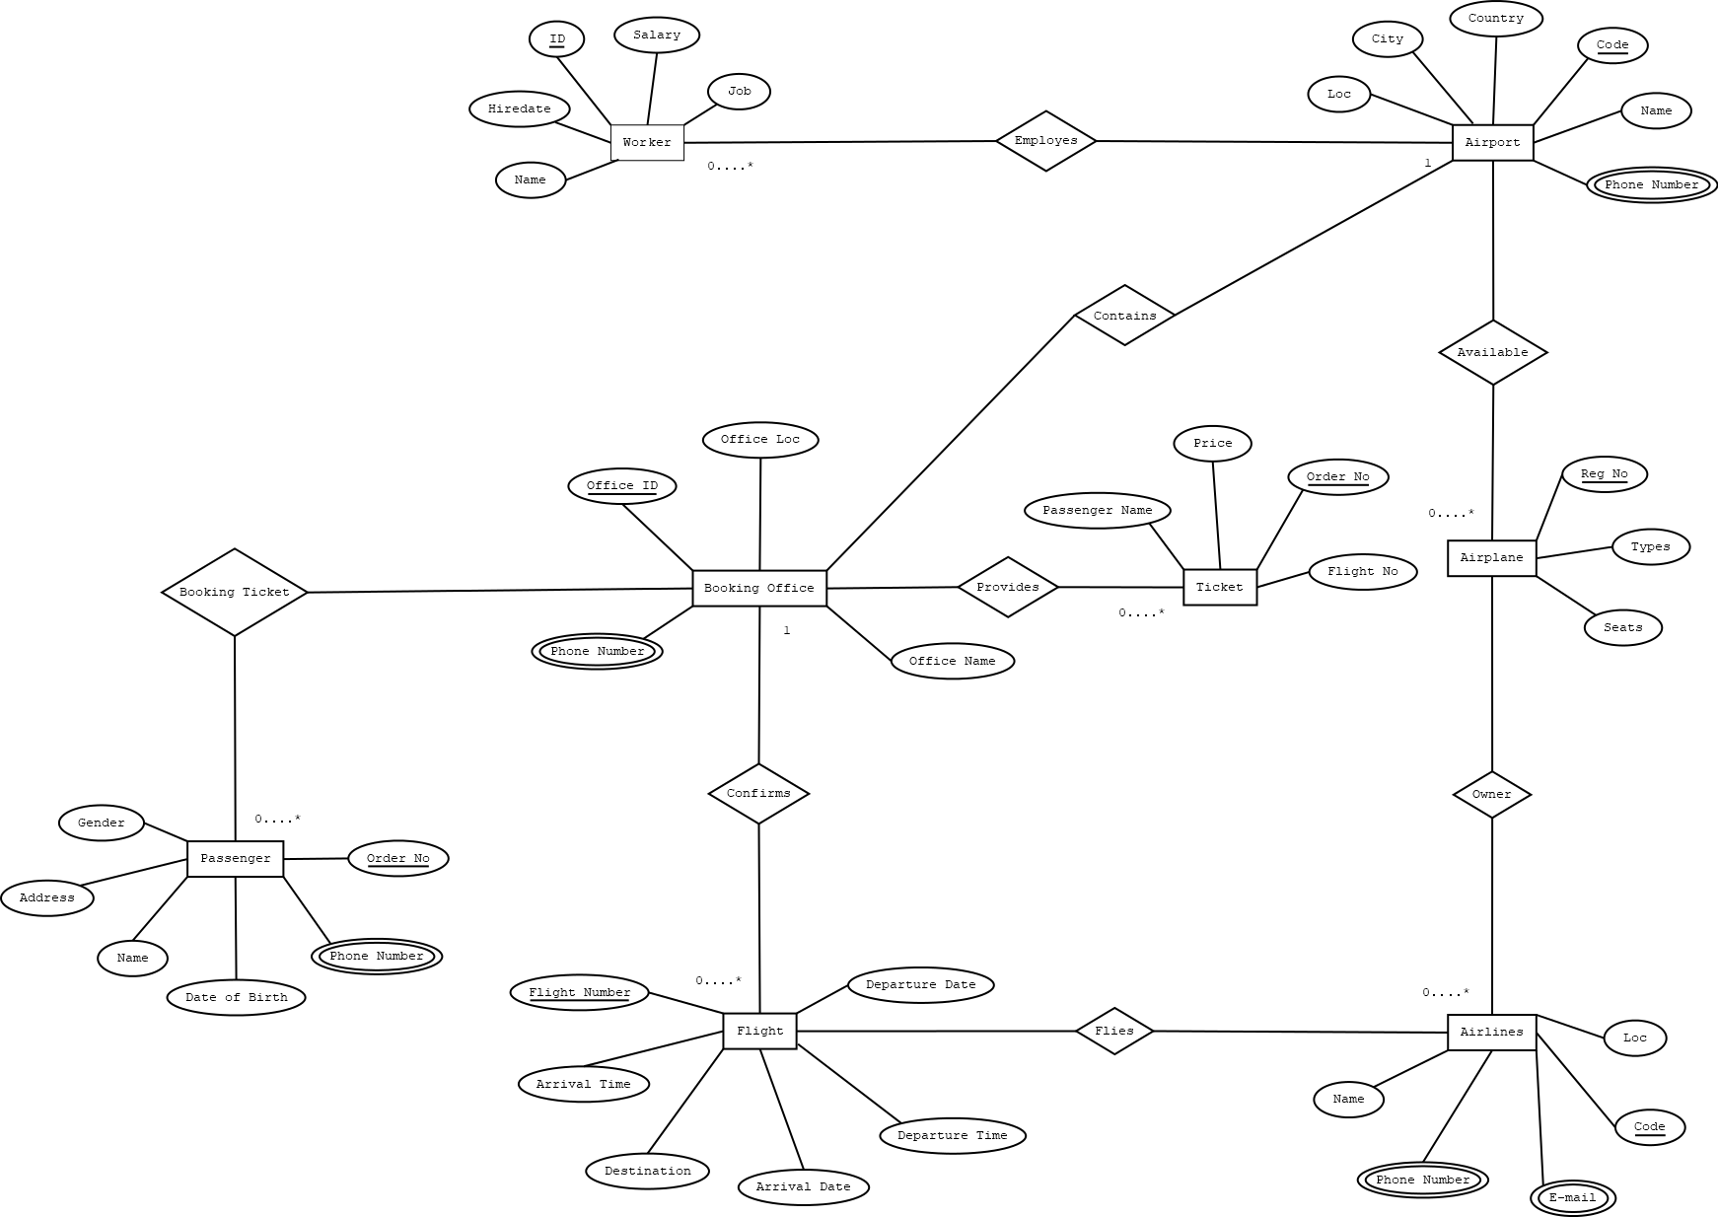**ER Diagram:**